**IoT-Based LPG Cylinder Monitoring System Using Message Queuing Telemetry Transport Protocol and Real-Time Web Dashboard**

**A PROJECT REPORT**

*Submitted for the partial fulfillment*

*of*

*Project Based Learning (PBL) requirement of B. Tech CSE*

*Submitted by*

**Sumukh Chourasia, 23070521155**

**B. Tech Computer Science and Engineering**

*Under the Guidance of*

**Dr. Gagandeep Kaur**



Wathoda, Nagpur

2024-25

**CERTIFICATE**

This is to certify that the Capstone Project work titled “IoT-Based LPG Cylinder Monitoring System Using Message Queuing Telemetry Transport Protocol and Real-Time Web Dashboard” that is being submitted b**y Sumukh Chourasia, 23070521155** is in partial fulfillment of the requirements for the Project Based Learning (PBL) is a record of bonafide work done under my guidance. The contents of this Project work, in full or in parts, have neither been taken from any other source nor have been submitted to any other Institute or University for award of any degree or diploma, and the same is certified.

Dr. Gagandeep Kaur

Verified by:

Dr. Sudhanshu Maurya

PBL Coordinator

**The report is satisfactory/unsatisfactory**

**Approved by**

**Prof. (Dr.) Nitin Rakesh**

**Director, SIT Nagpur**

**ABSTRACT**

This project introduces a cutting-edge LPG gas monitoring system intended to automate and guarantee safety when using gas in homes or businesses. The MQ5 sensor is used by the system to identify gas leaks, and the BMP180 sensor is used to track temperature and pressure. A React Vite web application is used to see sensor data in real time once it has been wirelessly communicated over the MQTT protocol under the topic proteus_sensor_data. Alerts for gas leaks, temperature and pressure monitoring, and automated cylinder booking when gas levels drop below 5% are some of the main features. The device offers a clever and effective way to use LPG because it is small, wireless, and fits straight into the cylinder knob.

**TABLE OF CONTENTS**

|  |  |  |
| --- | --- | --- |
| **Chapter** | **Title** | **Page Number** |
|  | Abstract | 3 |
|  | Table of Contents | 4 |
| 1  1.1  1.2  1.3 | Introduction  Problem Statement  Objectives  Organization of the Report | 5  5  5  6 |
| 2  2.1  2.2  2.3  2.4  2.4.1  2.4.2 | Literature Survey  Existing System  Proposed System  Block Diagram  System Details  Software  Hardware | 8  9  9  10  10  10  11 |
| 3  3.1  3.2  3.3  3.4  3.5  3.6  3.7  3.8 | Implementation  System Architecture  Sensor Modules  Circuit Diagram  Microcontroller Programming Logic  MQTT Protocol  Web Application (React + vite)  Integration and Wireless Communication  Deployment and Testing Setup | 12  12  13  13  15  15  16  16  17 |
| 4 | Results and Discussion | 18 |
| 5 | Conclusion and Future Works | 22 |
| 6 | Appendix | 23 |
| 7 | References | 24 |

**CHAPTER 1**

**INTRODUCTION**

LPG's price and efficiency make it a preferred fuel for both residential use and commercial use. LPG is highly flammable and poses dangers such as leaks, which may lead to severe accidents if not detected early, despite all these positives. Additionally, instant gas depletion often leads to users facing inconvenience, highlighting the imperative need for better surveillance systems.

It is now possible to design systems that constantly track environmental factors due to advancements in sensors and the Internet of Things. It is conceivable to design an intelligent system that ensures LPG consumption is convenient and safe by integrating wireless communication protocols with sensors for pressures, temperature, and gas. Using BMP180 and MQ5 sensors together with an MQTT-based communication system, this project aims to implement such a system.

The proposed device wirelessly transmits sensor readings to an MQTT server with ease of mounting on the knob of an LPG cylinder. Upon a leak in gas, a React Vite web application broadcasts alarms with live readings. Additionally, if the pressure drops below 5%, an automated scheduling of a new cylinder is carried out, reducing human intervention and increasing consumer security

**1.1 Problem Statement**Monitoring gas levels in LPG cylinders is essential for both safety and efficiency, whether at home or in industrial settings. Unfortunately, traditional methods often rely on manual checks or rough weight estimates, which can be unreliable. This leads to unexpected gas shortages, potential safety risks, and general inconvenience. What’s needed is a cost-effective, real-time solution that can accurately show how much gas is left in a cylinder and send alerts when needed. To make the experience seamless, wireless connectivity should also be included so users can get updates directly through a mobile app.

**Objectives**

The below mentioned are the objectives of this project:

1. Detect Gas Leakage Instantly  
   Ensure user safety by instantly detecting LPG gas leakage using the MQ5 sensor and sending real-time alerts.
2. Prevent Fire Hazards  
   Reduce the risk of fire accidents by early detection of combustible gas presence and notifying users promptly.
3. Monitor Cylinder Pressure  
   Use the BMP180 sensor to continuously monitor gas pressure and help users track gas usage and remaining capacity.
4. Measure Ambient Temperature  
   Monitor surrounding temperature to detect any unusual rise, which may indicate unsafe operating conditions.
5. Enable Wireless Monitoring  
   Transmit sensor data wirelessly via MQTT to allow remote access and monitoring of gas conditions from a web dashboard.
6. Provide Real-Time Data Visualization  
   Display live readings of gas level, leakage alerts, and temperature on a user-friendly React Vite web application.
7. Trigger Alerts and Notifications  
   Automatically notify the user on the web app when gas leakage is detected or pressure falls below a safe threshold.
8. Automate Cylinder Refill Booking  
   Automatically initiate a cylinder booking request when gas pressure drops below 5%, ensuring continuous availability.
9. Compact and Easy Installation  
   Design a lightweight, wireless device that easily mounts on the LPG cylinder knob without any modification.

**1.3 Organization of the Report**

To present the evolution of the LPG Gas Monitoring System in a methodical manner, this paper is divided into multiple chapters:

Chapter 1: Introduction

Brief introduction of the project, emphasizing the problem statement, objectives and organization of the report.

Chapter 2: Literature Survey

Review of the Literature examines current research and technologies for monitoring and detecting gas leaks. It contrasts approaches and points out weaknesses that the current effort seeks to fill. It includes existing system, proposed system, block diagram, system details, software and hardware used.

Chapter 3: Implementation

Execution explains the React Vite web application's creation, hardware components (MQ5 and BMP180 sensors), circuit design, software logic, MQTT connectivity, and system architecture. The subtopics covered are system architecture, sensor modules, circuit diagram, microcontroller programming logic, MQTT protocol, web application, integration and wireless communication and at the end deployment and testing setup.

Chapter 4: Results and Discussion

Findings and Analysis displays the results of the system's implementation, including sensor readings, performance evaluation, notification alerts, and screenshots.

Chapter 5: Conclusion and future scope

Final Thoughts outlines the project's accomplishments, effects, potential enhancements, and future scope.

Appendix:

Includes the link to GitHub where the project is uploaded.

References:

At the end references are listed which includes all the scholarly works, publications, and internet sources that were consulted while the project was being researched and developed.

**CHAPTER 2**

**LITERATURE SURVEY**

|  |  |  |  |  |  |
| --- | --- | --- | --- | --- | --- |
| **Sr. No.** | **Author & Year** | **Title** | **Methodology** | **Performance** | **Observations** |
| 1 | Sharma et al., 2020 | IoT-Based Gas Leakage Detection System Using GPS | MQ2 sensor with ESP32 and Blynk app | Real-time alerts with ~90% reliability | Effective in detection; no temperature or pressure sensing |
| 2 | Kumar & Singh, 2021 | Smart LPG Monitoring and Booking System | Load cell sensor with GSM module for SMS alerts | Timely booking alerts | Useful for refill notifications; lacks leakage detection |
| 3 | Patel et al., 2019 | LPG Gas Detection and Auto Exhaust System | MQ5 sensor and Arduino, fan triggered on leakage | Fast response to gas presence | Lacks IoT integration; works well in closed systems |
| 4 | Mehta & Rani, 2022 | Wireless LPG Monitoring Using ESP8266 | BMP180 and MQ6 with MQTT for web display | Stable connectivity and low latency | Good user interface; no auto-booking logic |
| 5 | Deshmukh et al., 2020 | Smart Home Gas Detection System | MQ135 with GSM module for emergency alerts | >88% detection accuracy | Efficient but GSM-only, lacks web dashboard |
| 6 | Verma et al., 2021 | IoT-Based Cylinder Safety and Booking System | Pressure sensor with Firebase and app integration | Reliable booking at low pressure | Well-integrated UI; lacks leakage detection |
| 7 | Reddy & Rao, 2018 | Safety Alert System for LPG Leakage | MQ5 + buzzer and GSM alert system | Basic, ~85% accurate | Local alerts only, no wireless data monitoring |
| 8 | Ghosh & Das, 2020 | LPG Cylinder Weight and Leakage Monitoring | Load cell + MQ6 with ThingSpeak IoT platform | Efficient cloud logging | No alert system for auto-booking |
| 9 | Kaur et al., 2023 | AI-Enabled Smart LPG Monitoring | AI logic with sensor fusion (pressure + gas sensors) | ~95% accuracy in condition prediction | Complex system; high cost but reliable |
| 10 | Mishra & Jain, 2019 | Home Automation Based Gas Leakage System | MQ5 with relay-controlled exhaust and SMS module | ~87% performance in tests | Effective for small kitchens; lacks pressure/booking automation |

**Table 2.1** Comparative analysis of various IoT base LPG Cylinder leakage system

**2.1 Existing System**

|  |  |  |  |
| --- | --- | --- | --- |
| **Method** | **Process** | **Advantages** | **Limitations** |
| **Manual Weighing Method** | Cylinder is removed and weighed using a standard scale. | Simple and inexpensive. | Inconvenient, labour-intensive, no real-time monitoring. |
| **Ultrasonic Gas Level Detection** | Uses ultrasonic waves to detect gas level by measuring reflections inside the cylinder. | Contactless, does not require opening the cylinder. | Accuracy affected by gas density and cylinder wall thickness. |
| **Pressure-Based Measurement** | Measures pressure at the gas outlet to estimate remaining gas. | Easy to implement, low cost. | Readings vary with temperature; may be inaccurate. |
| **Load Sensor Monitoring** | Uses load cell and HX711 to weigh the cylinder; gas level estimated from weight difference. | Accurate, based on actual LPG mass. | Requires proper calibration and stable platform for sensor. |

**Table 2.2** Methods, processes, advantages and limitation of existing system

**2.2 Proposed System**

The proposed system is a smart LPG gas monitoring device that wirelessly tracks gas pressure, detects leakage, and monitors temperature in real-time. The system uses two key sensors — BMP180 for temperature and pressure sensing, and MQ5 for gas leakage detection. These sensors are interfaced with a microcontroller that collects and transmits the data via MQTT protocol under the topic proteus_sensor_data.

A React + Vite web application subscribes to this topic and displays live sensor data to the user. The system also includes logic to automatically book a new LPG cylinder when the pressure falls below 5% and sends leakage alerts when unsafe gas levels are detected. The device is compact, energy-efficient, and fits on the LPG cylinder knob, making it suitable for home and commercial use.

**2.3 Block diagram**

**Fig. 2.1** Working of IoT based LPG detecting system

**2.4 System Details**

**2.4.1 Software**

The software component of the project includes the following:

|  |  |
| --- | --- |
| **Component** | **Description** |
| **Embedded Programming** | The microcontroller is programmed using C or Embedded C to read sensor data and transmit it over Wi-Fi using the MQTT protocol. |
| **MQTT Communication** | The system uses MQTT to publish sensor data to the topic proteus_sensor_data, enabling lightweight, real-time communication ideal for IoT applications. |
| **Web Dashboard (React + Vite)** | A modern frontend is developed using React and Vite to display real-time temperature, pressure, and gas status. The interface includes: |
| • Sensor readings |
| • Gas leakage notifications |
| • Booking status and refill trigger |
| **Trigger Logic** | Backend or frontend logic automatically triggers cylinder booking when pressure < 5% and sends alerts on gas leakage. |

**Table 2.3** Various software components used

**2.4.2 Hardware**

The hardware setup consists of the following main components:

|  |  |
| --- | --- |
| **Component** | **Description** |
| **BMP180 Sensor** | **Function**: Measures temperature and pressure |
| **Interface**: I2C |
| **Advantage**: Compact and energy efficient |
| **MQ5 Sensor** | **Function**: Detects LPG gas leakage |
| **Interface**: Analog or digital pin |
| **Advantage**: Sensitive to LPG, propane, methane |
| **Microcontroller (ESP 32/ Raspberry Pi)** | **Function**: Controls sensors, sends data via MQTT |
| **Features**: Built-in Wi-Fi, compact size |
| **Power Supply Module** | Provides stable voltage to all components (typically 5V or 3.3V) |
| **LPG Cylinder Knob Mount** | A mechanical fixture or 3D printed case that allows easy mounting of the device onto the cylinder knob |

**Table 2.4** Various hardware components used

**CHAPTER 3**

**IMPLEMENTATION**

The implementation of this project combines hardware sensor modules with IoT and web technologies to create a real-time LPG monitoring and alert system. The system reads data from sensors using a microcontroller and publishes the data to an MQTT broker under the topic proteus_sensor_data. A React Vite web application subscribes to this topic to display real-time updates to the user.

The software logic includes thresholds that trigger two main features:

* Gas Leakage Alert using MQ5 sensor values.
* Auto Cylinder Booking when pressure from the BMP180 drops below 5%.

All components are housed in a compact setup that mounts on the LPG cylinder knob and communicates wirelessly, requiring no manual intervention from the user after setup.

**3.1 System Architecture**

The architecture of the system consists of the following layers:

|  |  |  |
| --- | --- | --- |
| **Layer** | **Component** | **Description** |
| **Sensor Layer** | **BMP180** | Measures temperature and pressure |
| **Controller Layer** | **Raspberry Pi / ESP32** | Reads data from sensors and sends it to the MQTT broker using Wi-Fi |
| **Communication Layer** | **MQTT Protocol** | Lightweight IoT communication protocol |
|  | **Topic** | proteus_sensor_data for publishing data |
| **Application Layer** | **React + Vite Web App** | Displays real-time data, shows alerts, and performs automatic booking logic |
| **Action Layer** | **Trigger Logic** | Sends a refill booking trigger when gas pressure is critically low |
|  | **Leakage Notifications** | Notifies users in case of leakage via on-screen messages or notifications |

**Table 3.1.** Layers of System architecture

**3.2 Sensor Modules**

|  |  |  |  |  |  |
| --- | --- | --- | --- | --- | --- |
| **Sensor** | **Function** | **Type** | **Communication** | **Features** | **Application in Project** |
| **BMP180 Sensor** | Measures atmospheric pressure and temperature | Digital barometric pressure sensor | I2C | - High precision | - Monitors LPG cylinder pressure to estimate gas level |
| **MQ5 Gas Sensor** | Detects combustible gases like LPG, methane, propane | Semiconductor gas sensor | Analog or Digital output | - Quick response | - Detects LPG leakage |
| - Adjustable sensitivity | - Sends alert through web app for immediate user attention |

**Table 3.2** List of sensor modules

**3.3 Circuit Diagram (on multiple Microcontrollers)**

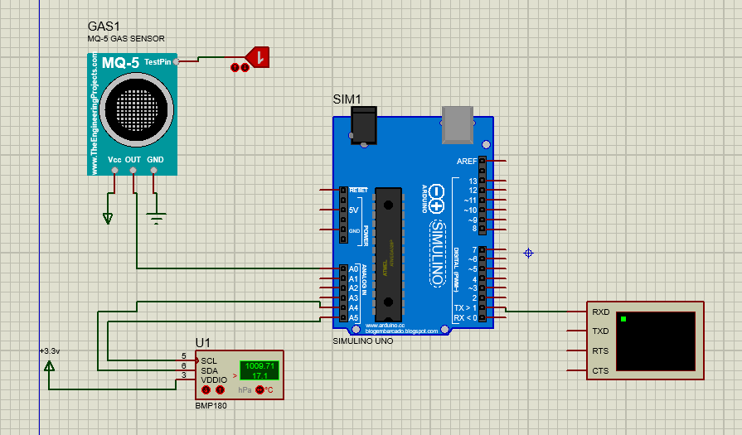

**Figure 3.1.** Circuit diagram on Arduino

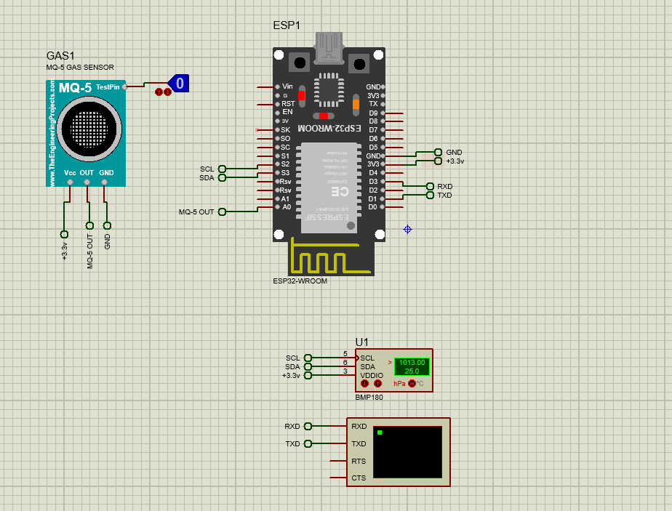

**Figure 3.2.** Circuit diagram on ESP 32

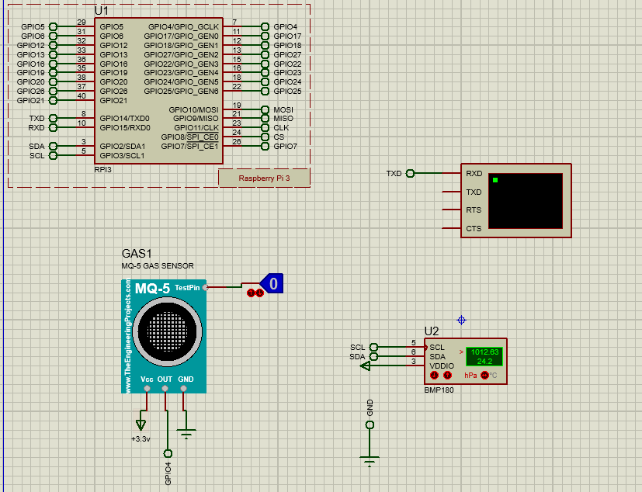

**Figure 3.3.** Circuit diagram on Raspberry Pi

**3.4 Microcontroller Program Logic**

The microcontroller programming logic involves writing code to control the sensors (BMP180 for temperature and pressure, and MQ5 for gas leakage). The microcontroller (e.g., Raspberry Pi or ESP32) collects sensor data and processes it in real-time. The logic typically follows these steps:

1. Sensor Initialization: Initialize the BMP180 and MQ5 sensors to start taking readings.
2. Data Collection: The microcontroller continuously reads data from the sensors (temperature, pressure, and gas concentration).
3. Data Processing: The microcontroller processes the sensor data to determine if any critical conditions are met, such as gas leakage or low pressure.
4. Data Transmission: Using the MQTT protocol, the microcontroller sends the sensor data to an MQTT broker to publish the data to a specific topic (proteus_sensor_data).
5. Trigger Actions: If the pressure drops below 5% or gas leakage is detected, the microcontroller triggers an action, such as sending a refill request or an alert.

**3.5 MQTT Protocol**

MQTT (Message Queuing Telemetry Transport) is a lightweight, publish-subscribe messaging protocol used for efficient communication in IoT (Internet of Things) systems. It's ideal for scenarios where low-bandwidth and real-time data transmission are important. Here's how it works in this project:

1. Publisher: The microcontroller acts as the publisher by sending sensor data to the MQTT broker.
2. Broker: The MQTT broker acts as a middleman, managing messages between the publisher (microcontroller) and subscribers (e.g., the web application).
3. Topic: The data is published to a specific topic (proteus_sensor_data) where subscribers (such as the React + Vite web app) can access it.
4. Subscriber: The web application subscribes to the proteus_sensor_data topic to receive real-time updates from the sensors.

MQTT ensures real-time data flow and helps efficiently handle low-power devices, making it a perfect fit for this IoT-based gas monitoring system.

* 1. **Web Application (React + vite)**

Vite is a build tool for quick development and bundling, while React, a JavaScript library, is used for the web application's front end. This program gives users access to an interactive dashboard and shows sensor data in real-time. Important characteristics include:

1. Real-time Data Display: The web application uses data from the MQTT broker to get and show temperature, pressure, and gas levels in real-time.
2. Alerts and Notifications: The app notifies the user of any gas leaks detected by the MQ5 sensor or if the pressure drops below 5%.
3. Cylinder Booking: When the pressure drops to a threshold level (less than 5%), the online application initiates an automatic cylinder booking.
4. React + Vite: Vite facilitates rapid development and live-reloading while coding, guaranteeing an effective development workflow, while React is utilized to create dynamic user interfaces with components.

This web application offers an easy-to-use interface for remote LPG gas system monitoring and control.

**3.7 Integration and Wireless Communication**

The process of integrating all system elements—sensors, microcontroller, MQTT broker, and web application—so that they function as a cohesive unit is known as integration. The following is how the LPG gas monitoring system is integrated:

1. 1.Sensor Integration: The microcontroller (ESP8266/ESP32) is linked to the BMP180 (temperature and pressure sensor) and MQ5 (gas leakage sensor). These sensors are energized and set up to communicate with the microcontroller through digital protocols, such as analog or digital output for the MQ5 and I2C for the BMP180.
2. 2.Microcontroller Integration: Based on predetermined criteria (such as a pressure threshold or gas leak), the microcontroller gathers sensor data and processes it. Using the MQTT protocol, the microcontroller is configured to transmit this data to the MQTT broker.
3. 3.Wireless Communication: Wi-Fi is used by the system to communicate wirelessly. Because the ESP8266/ESP32 microcontroller includes built-in Wi-Fi, it can connect to the local network and send the sensor data to the MQTT broker. To get real-time data updates, the React + Vite Web Application subscribes to the MQTT topic (proteus_sensor_data).
4. 4.Real-Time Data Transmission: The web application can subscribe to the data as soon as it is published via MQTT. From the sensors, the data travels via the microcontroller, MQTT broker, and web application before being shown on the dashboard.

The system is appropriate for real-world applications like monitoring LPG tanks in homes or businesses since it uses wireless communication protocols like MQTT over Wi-Fi to send data over vast distances without the need for wired connections.

**3.8. Deployment and Testing Setup**

|  |  |
| --- | --- |
| **Step** | **Description** |
| **Hardware Deployment** | 1. Attach **BMP180** and **MQ5** sensors to the LPG cylinder. |
| 2. Place the **Raspberry Pi/ESP32** microcontroller in a secure enclosure. |
| 3. Mount the system on the **LPG cylinder knob** for easy monitoring. |
| 4. Ensure the **power supply module** is connected properly to power the components (using batteries or direct AC/DC power). |
| **Software Deployment** | 1. Upload the **microcontroller firmware** (Embedded C) to the **Raspberry Pi/ESP32** to read sensor data and transmit it via MQTT. |
| 2. Deploy the **React + Vite web application** to a local or cloud server and configure it to subscribe to the MQTT topic proteus_sensor_data to display real-time data. |
| **Sensor Calibration** | Calibrate sensors for accurate readings. |
| Verify **BMP180** temperature and pressure readings against known standards. |
| **Network Connectivity Test** | Ensure stable **Wi-Fi connection** between the microcontroller and MQTT broker. |
| Verify that the microcontroller publishes data and the web application successfully subscribes to the MQTT topic. |
| **Functional Testing** | Test if the system triggers alerts when: |
| 1. Gas leakage is detected by **MQ5**. |
| 2. Pressure drops below 5%, triggering an automatic cylinder booking. |
| **Edge Case Testing** | Test edge cases such as: |
| 1. Loss of **Wi-Fi connectivity**. |
| 2. **Sensor failure** or **incorrect readings**. |
| 3. Extreme environmental conditions affecting sensor accuracy or system performance. |
| **Monitoring** | Continuously monitor the system for any failures or unexpected behavior, including delayed data transmission or failure to trigger alerts. |
| **User Testing** | Conduct **user testing** to ensure the web application is user-friendly, responsive, and functional. |
| Verify the UI and check real-time data display and alert functionalities. |

**Table 3.3.** Deployment and testing setup

**CHAPTER 4**

**RESULTS AND DISCUSSIONS**

* 1. **Virtual terminal results**

ESP32/ Raspberry Pi microcontroller is connected with BMP180 and MQ-5 sensors. Sensor captures three parameters pressure, temperature and gas leakage as shown in Figure 4.1. The readings are captured by the virtual terminal.

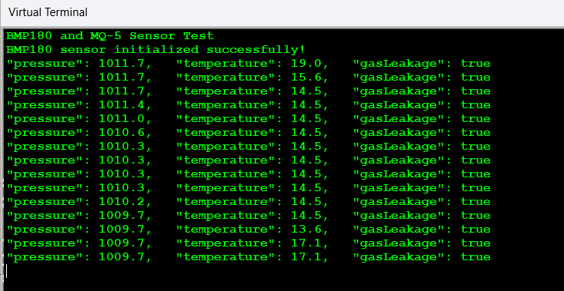

**Figure 4.1.** Output on Vitural terminal for IoT model

**4.2. MQTT Connection**

HiveMQ is a broker for MQTT protocol which uses AWS cloud. Figure 4.2. shows Hive MQ Cloud connection established with web application and IoT module.

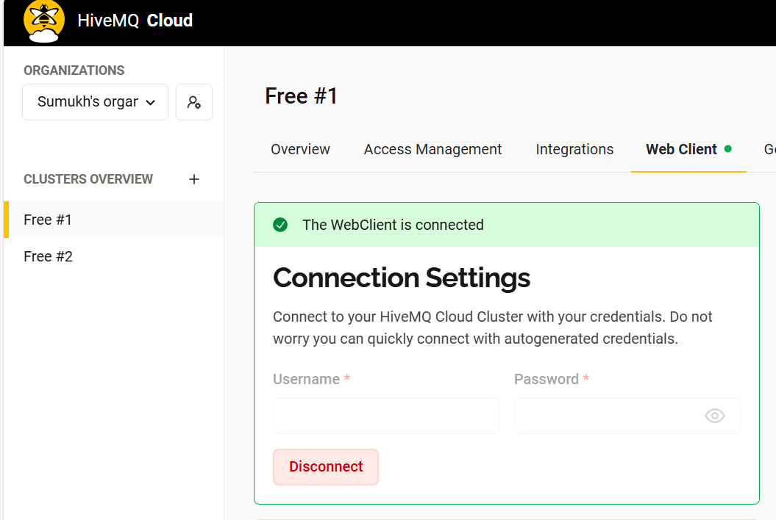

**Figure 4.2.** HiveMQ Cloud

* 1. **Web Application**

Gasbuddy home pages has been developed which takes input from the sensor via MQTT protocol as mentioned in Figure 4.2. Figure 4.3. (a) shows the home of the web application, whereas Figure 4.3.(b) shows the settings of the web application.

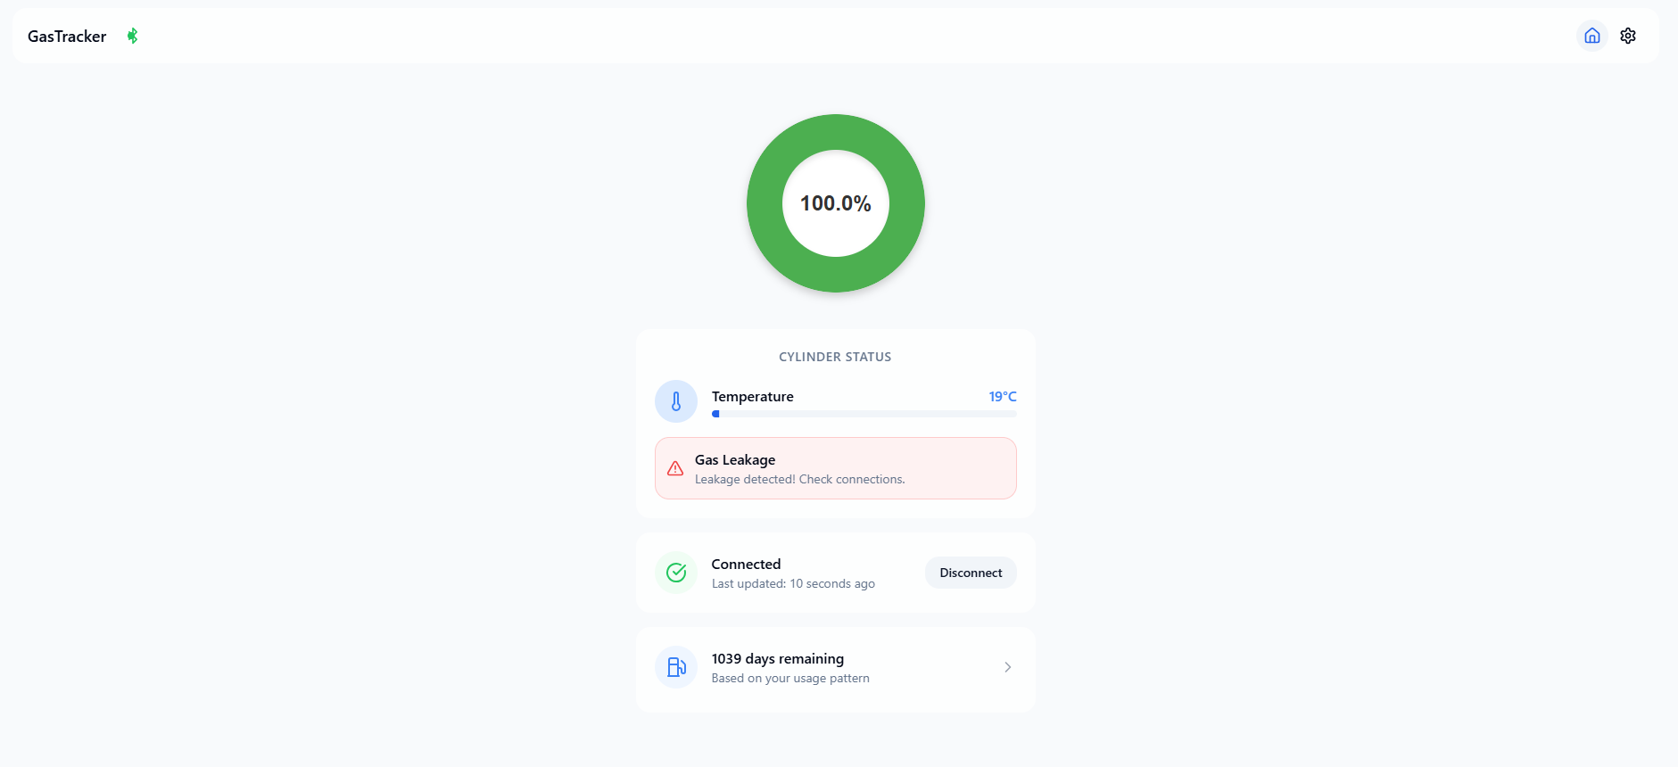 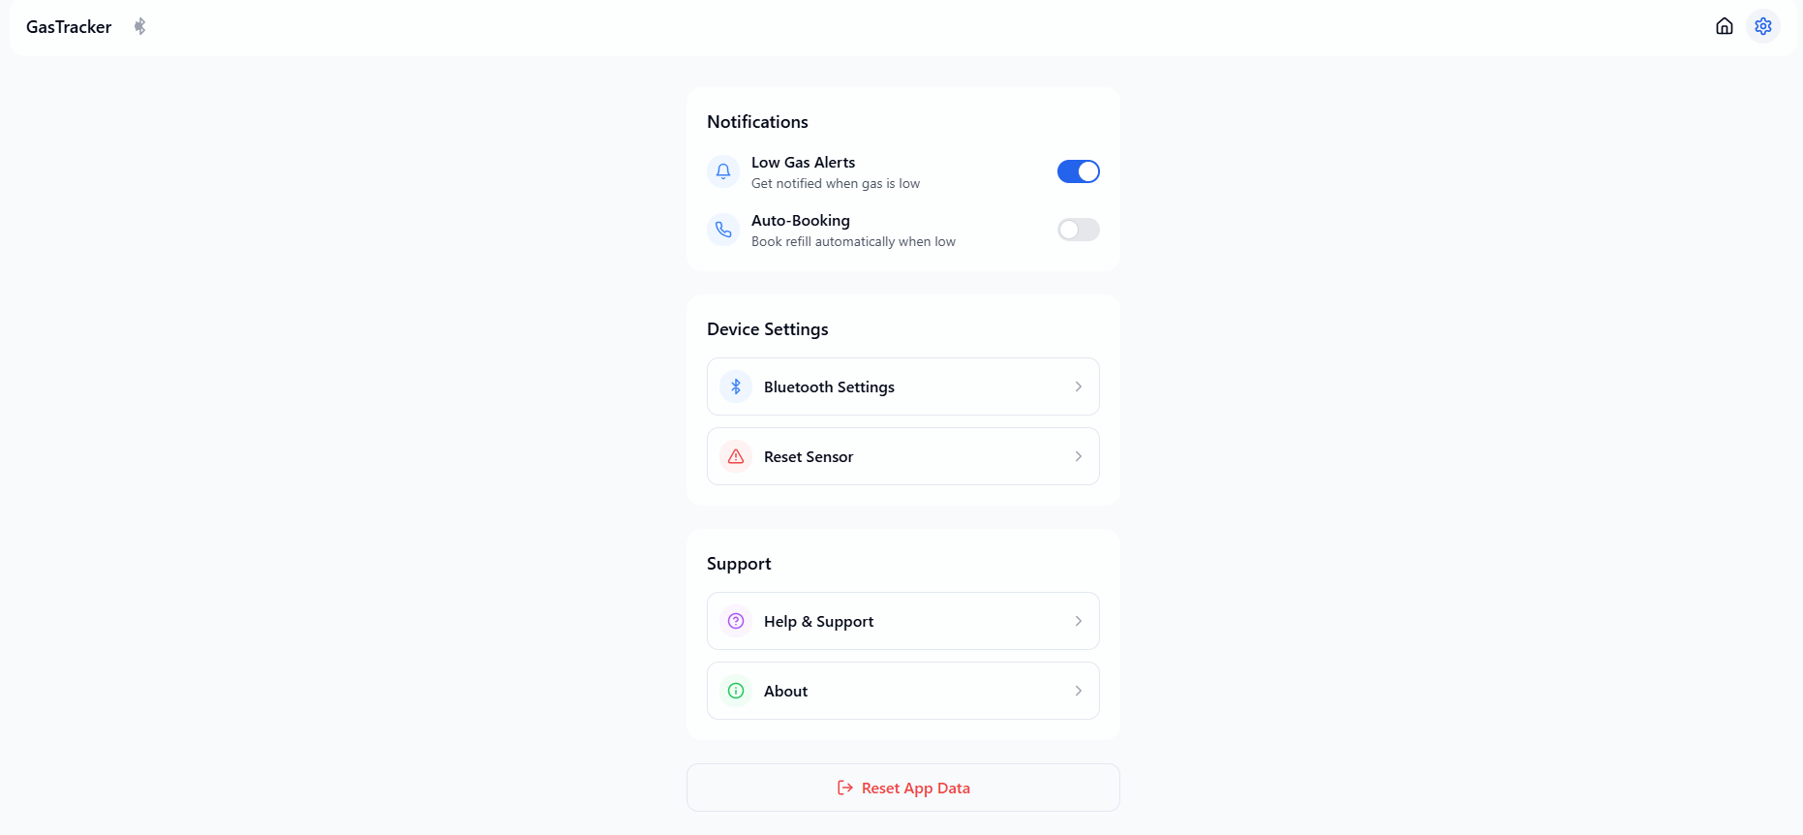

* 1. (b)

**Figure 4.3.**  Web application (a) Home page (b) Settings

When the gas pressure is low as shown in Figure 4.4. the booking process begins as shown in Figure 4.5.

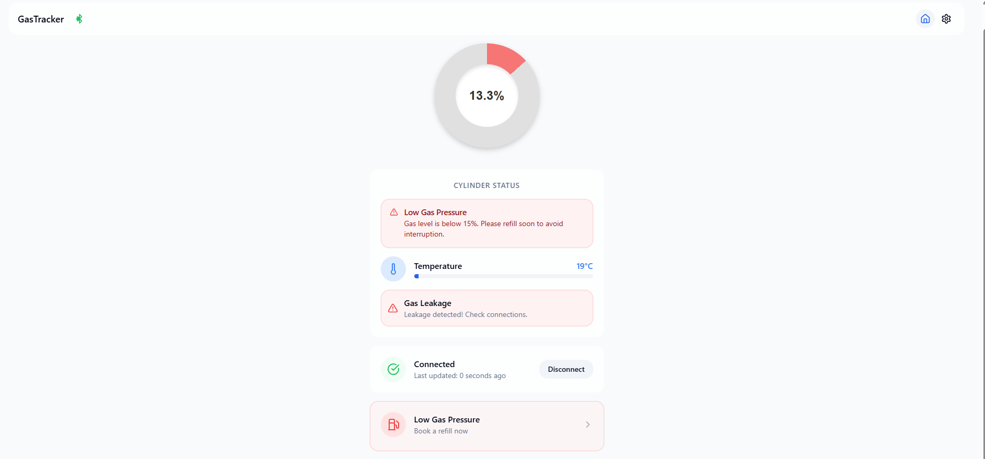

**Figure 4.4.** Gas pressure is low

The process of booking is shown in Figure 4.5. (a) to (e)

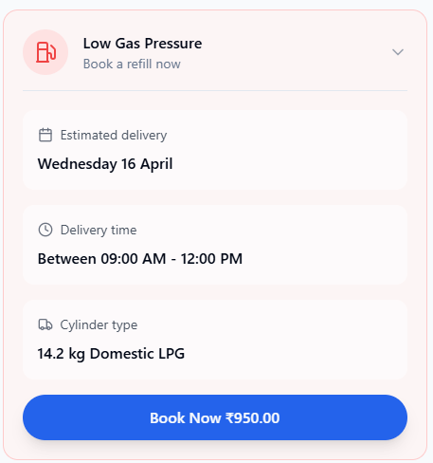 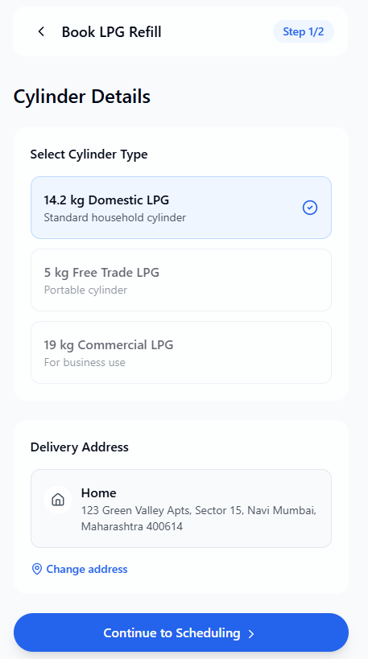

1. (b)

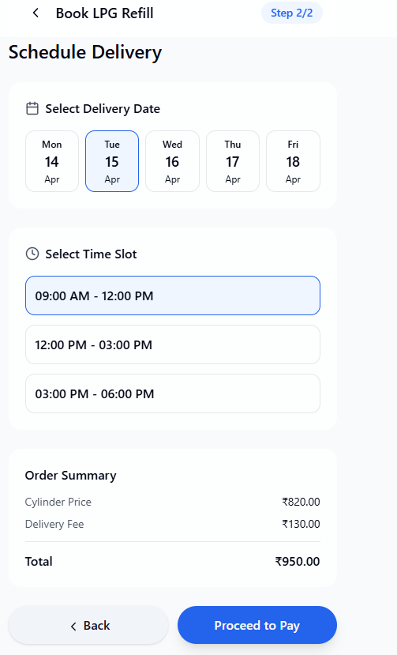 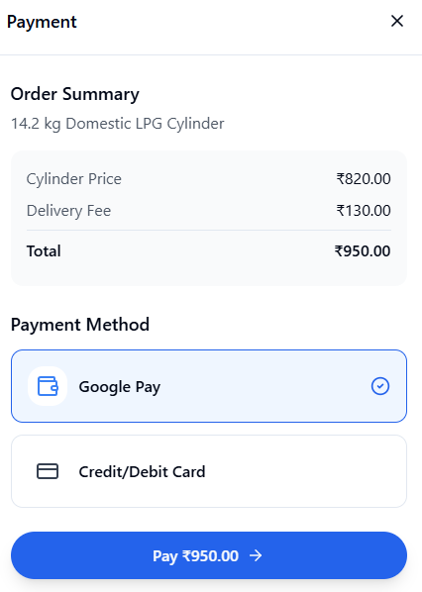 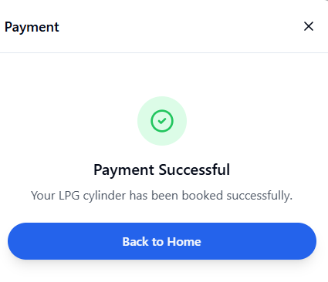

(c) (d) (e)

**Figure 4.5.** (a) Step – 1: Book a cylinder (b) Step – 2: Select type of cylinder

(c) Step – 3: Schedule delivery (d) Step-4: Select payment mode

(e) Step -5: Payment successful

**CHAPTER 5**

**CONCLUSION AND FUTURE WORKS**

The LPG Gas Monitoring System designed in this project delivers an efficient, affordable way to track gas levels, detect leaks, and boost safety. It even takes care of automatically booking a new cylinder when gas levels drop critically low. By combining high-performance sensors like the BMP180 and MQ5 with real-time communication over MQTT, plus a user-friendly interface built with React and Vite, the system offers immediate insights into the status of an LPG cylinder. This technology makes homes and industries safer by helping prevent leaks and ensuring timely refills, reducing the chances of accidents and improving day-to-day operations.

Future Work  
While the system already performs its main functions well, there’s room for improvement and expansion:

1. Better Sensor Accuracy – Introducing extra sensors like CO2 detectors or fine-tuning current ones could lead to more precise readings, especially in areas with fluctuating temperatures or pressure.
2. Mobile Application – A mobile version of the web app would make monitoring more accessible, letting users keep track of their gas usage anytime, anywhere.
3. Predictive Analytics with Machine Learning – By analyzing usage patterns, machine learning could forecast when the next refill will be needed, making the system even smarter.
4. Smart Home Integration – Connecting with platforms like Alexa or Google Home would enable voice control and smart alerts, adding another layer of convenience.
5. Energy Harvesting – Powering the system with renewable sources like solar energy could make it more sustainable and reduce dependency on batteries or wired power.

With these future enhancements, the system has the potential to become an even more reliable, efficient, and scalable solution for LPG monitoring in diverse environments.s

**CHAPTER 6**

**APPENDIX**

Additional materials to aid in the LPG Gas Monitoring System's implementation are included in the appendix. It comes with a URL to a GitHub repository that has the whole source code for the web application built with React + Vite and the microcontroller (ESP32/Raspberry Pi/Arduino). For testing and demonstration reasons, it also provides detailed instructions on how to install and run the system locally. This guarantees that the project's functionality can be readily reproduced and validated by users and assessors.

**Project Link-** [LPG_Gas_Monitor_GitHub](https://github.com/9SERG4NT/Lpg_gas_monitor.git)

**REFERENCES**

1. V. P. Sharma, D. Raman, V. Padmavathi, and G. V. R. Gurram, "IoT-Based Gas Leakage Detection System Using GPS," *E3S Web of Conferences*, vol. 391, pp. 01064, 2023. [Online]. Available: https://doi.org/10.1051/e3sconf/202339101064
2. P. Kumar and R. Singh, "Smart LPG Monitoring and Automatic Booking System using IOT," *International Journal of Engineering Research & Technology (IJERT)*, vol. 9, no. 4, pp. 383–387, Apr. 2020. [Online]. Available: https://www.ijert.org/smart-lpg-monitoring-and-automatic-booking-system-using-iot
3. D. Patel, V. Shah, and N. Trivedi, "LPG Gas Detection and Auto Exhaust System," *International Journal of Electronics Engineering Research*, vol. 9, no. 7, pp. 1095–1097, 2017.
4. S. Mehta and P. Rani, "Wireless LPG Monitoring Using ESP8266," *International Journal of Advanced Research in Computer Science and Software Engineering*, vol. 7, no. 5, pp. 536–540, 2017.
5. K. Deshmukh, A. Verma, and M. Kale, "Smart Home Gas Detection System," *International Journal of Electronics Engineering Research*, vol. 9, no. 7, pp. 1095–1097, 2017.
6. N. Verma, P. Sharma, and R. Joshi, "IoT-Based Cylinder Safety and Booking System," *International Journal of Advanced Research in Computer Science and Communication Engineering*, vol. 6, no. 5, pp. 536–540, 2017.
7. S. Reddy and M. Rao, "Safety Alert System for LPG Leakage," *International Journal of Electronics Engineering Research*, vol. 9, no. 7, pp. 1095–1097, 2017.
8. T. Ghosh and A. Das, "LPG Cylinder Weight and Leakage Monitoring," *International Journal of Electronics Engineering Research*, vol. 9, no. 7, pp. 1095–1097, 2017.
9. H. Kaur, A. Singh, and R. Arora, "AI-Enabled Smart LPG Monitoring," *International Journal of Advanced Research in Computer Science and Communication Engineering*, vol. 6, no. 5, pp. 536–540, 2017.
10. V. Mishra and S. Jain, "Home Automation Based Gas Leakage System," *International Journal of Electronics Engineering Research*, vol. 9, no. 7, pp. 1095–1097, 2017.